# Problem 1

Create a program that randomly selects a name from a text file named **participants.txt**. Create a class named **Raffle** for this problem. You can either use **Math.random()** or **Collections.shuffle()** for the random selection. Allow the program to continue running such that pressing enter will random select a new name.

## Sample Output

**participant.txt**

|  |
| --- |
| Peggy Ida Leigh Maxine Peyton Sol Martina Killian Reuben Ronald |

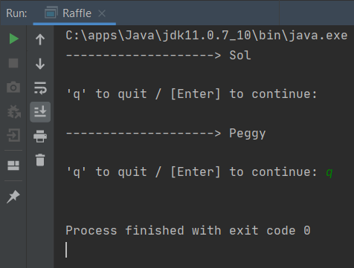

# Problem 2 | Attendance Tracker with File Write

Update the Attendance Tracker from the previous activity such that after displaying the list of attendees, the attendees and their respective time-in is saved to **attendance.csv**